A

REPORT

ON

MOVIE SHOW 2025

SRSSION 2024-2025

DEPARTMENT OF PHILOSOPHY

Rabindra Mahavidyalaya

Champadanga, Hooghly

Theme: MOVIE SHOW 2025

Venue: Rabindra Mahavidyalaya, champadanga

Department of Philosophy,

room no. 69

Date: 3rd January 2025

Organizer: Department of Philosophy

Objectives:
- To improve critical thinking and empathy, and provide historical and social context.
- Motivating Students to "Restart”
- To Highlighting the Value of Hard Work and Discipline
- Failure is not the end of life, but an opportunity to start anew.
- Any goal can be achieved through honesty and hard work.

Notice
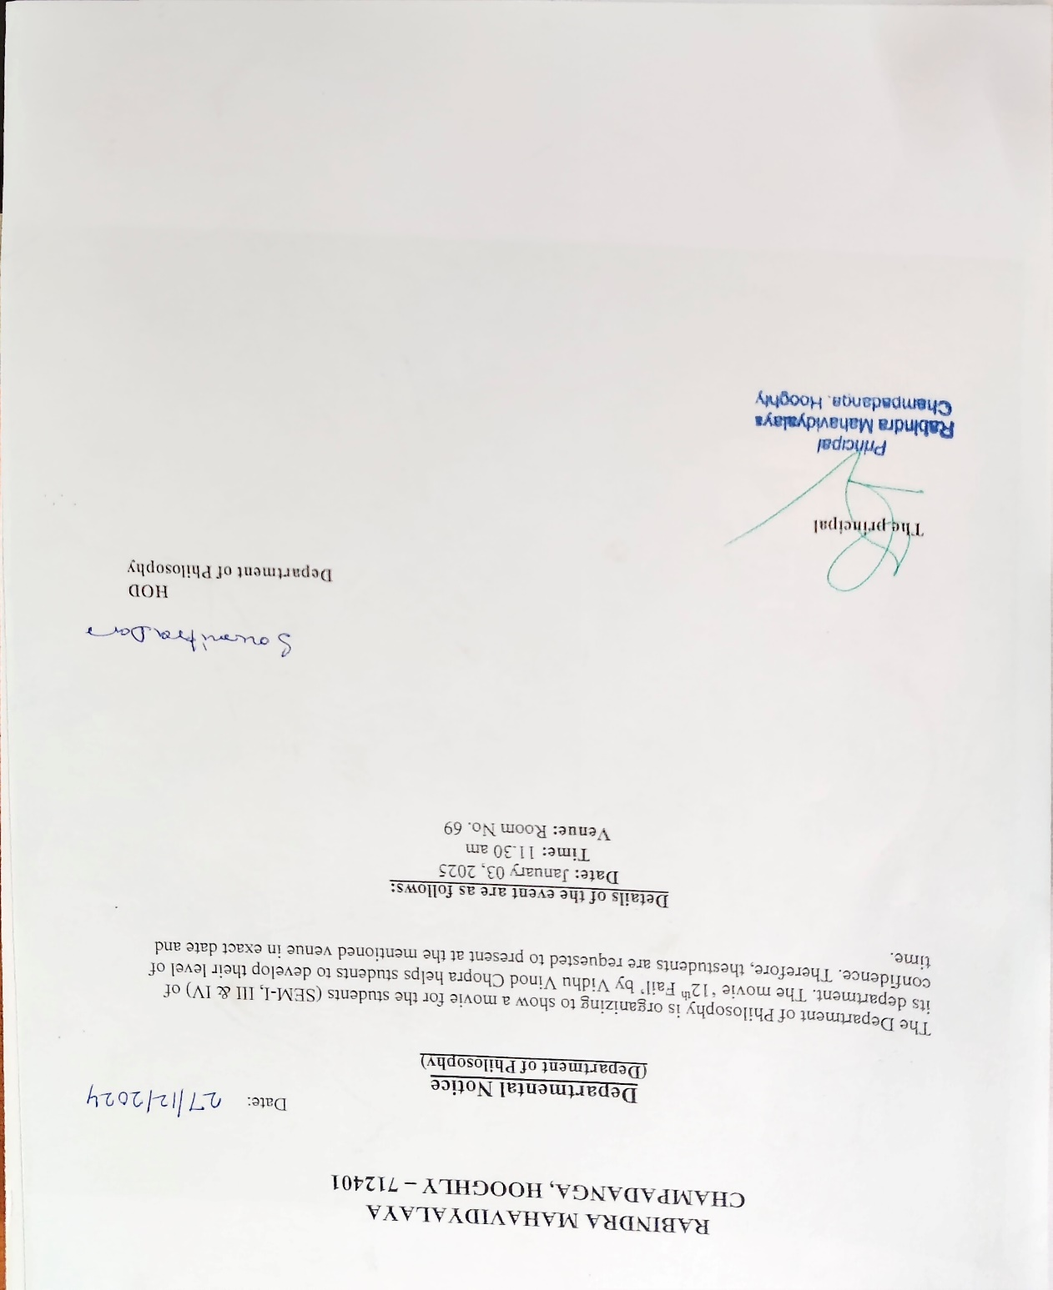

summary

On 3rd January 2025 the department of philosophy organized a movie show for students. Arrangements were made to screen the inspirational Hindi film "12th Fail. The film, based on the real-life story of an IPS officer named Manoj Kumar Sharma, has received a great response among the students. The main objective of the film screening was to instill in the students a mindset of perseverance, honesty and fighting against adversity. Failure is not the end of life, but an opportunity to start anew. Any goal can be achieved through honesty and hard work.
Social or economic background should not be a barrier to a person fulfilling their dreams.
Emotional support from friends and family is very important for success.
After screening the film, a huge positive impact was observed among the students. Many admitted that this film taught them to look at failure in their lives in a different way.
In the discussion session organized after the screening, the students expressed their thoughts. They discussed various aspects of the film, such as the concept of "Restart" and the importance of mental strength. Students who were suffering from disappointment in their studies or in any other field, gained the confidence to try again after watching this film.
"Twelfth Fail" movie is a life-oriented education. Screening such films is very effective in instilling the right values and a positive outlook towards life among the students. This initiative was successful and there are plans to take up more such inspirational activities in the future.

Tentative programmed schedule
- Introduction session: 11.30a.m. to 11.45 a.m.
- Movie start :12. 00p.m
- Discussion session: 3.30pm

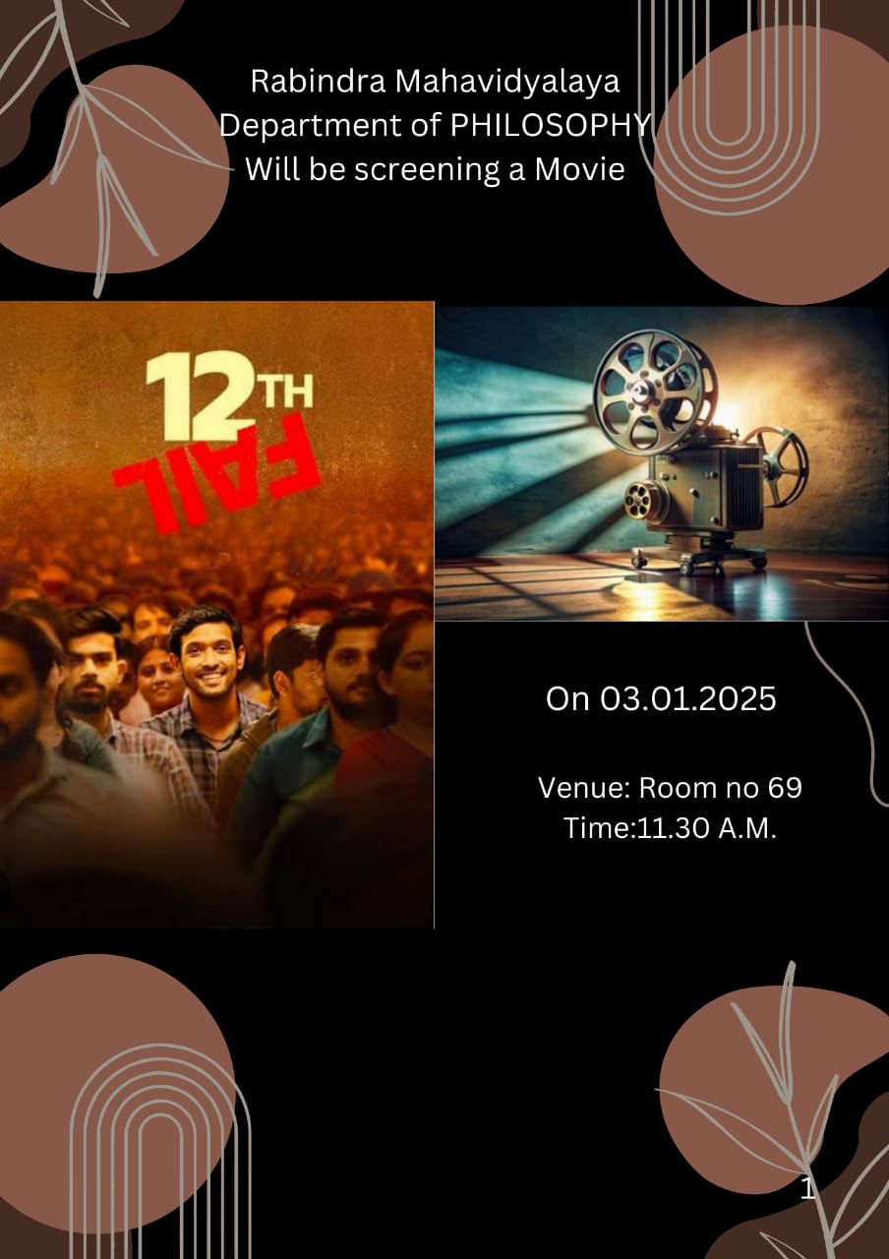
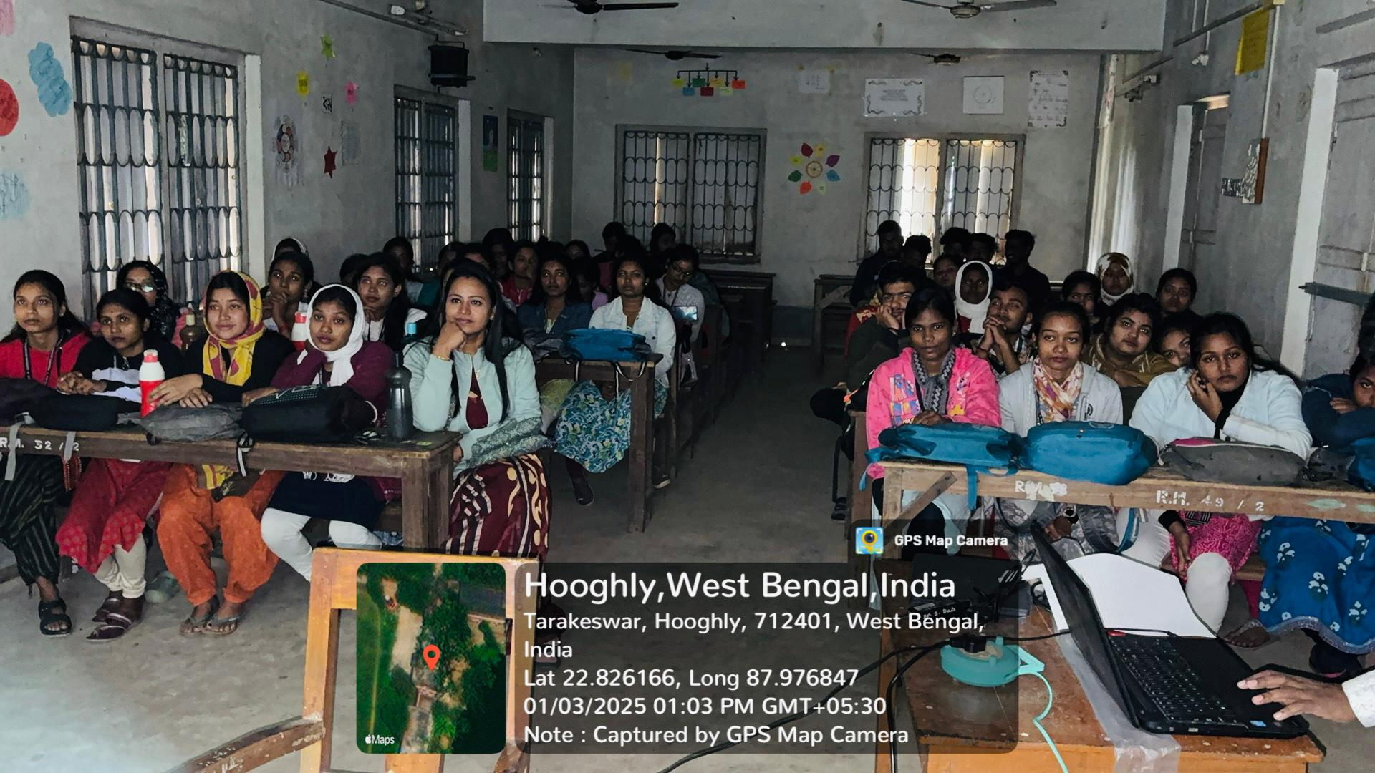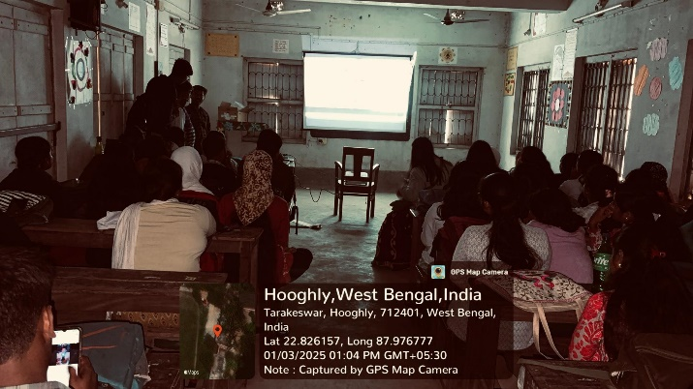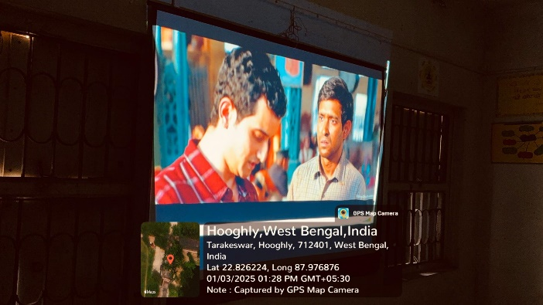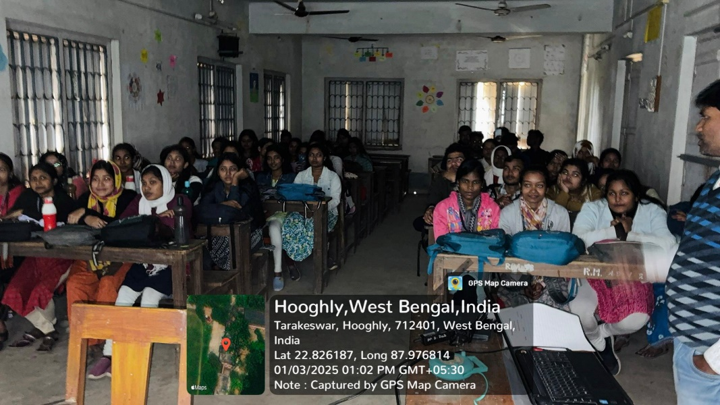

Attendance Sheet
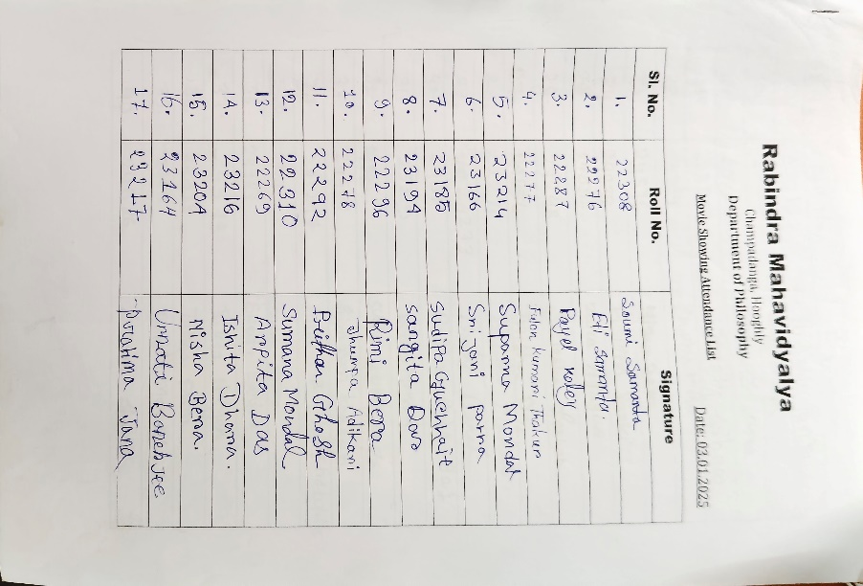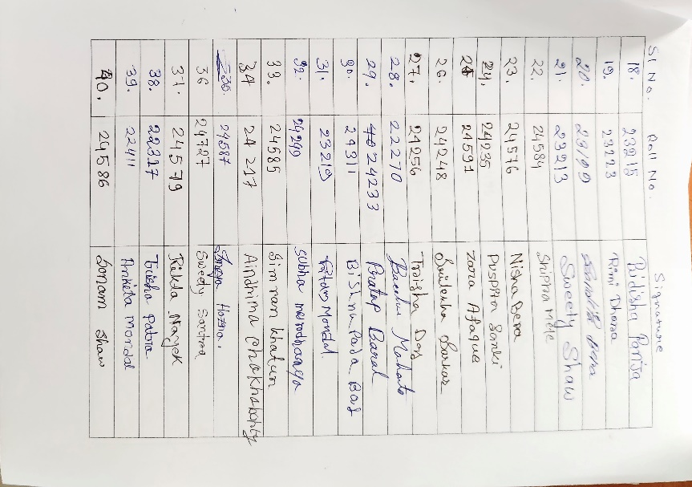
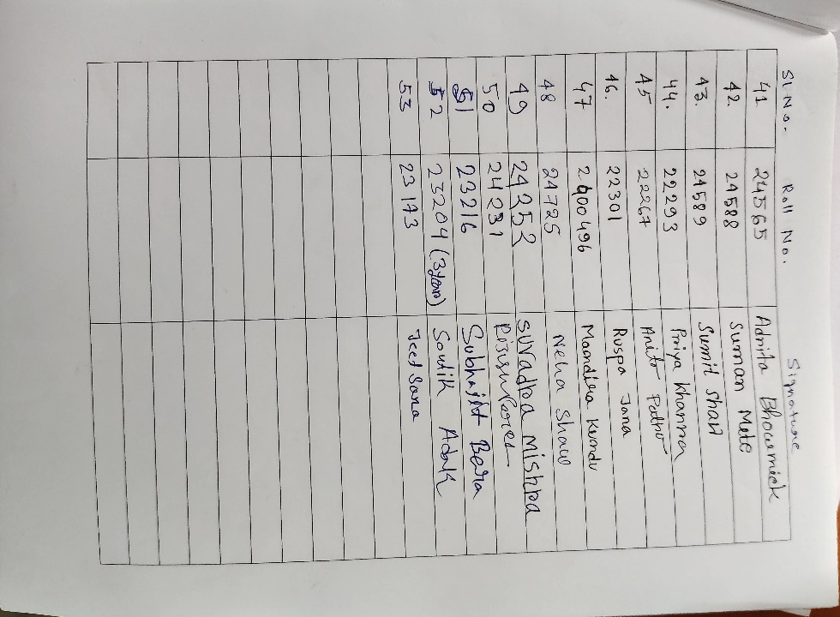
Attendance: 53
Male: 13
Female:40

Feedback from students:
- 90% felt satisfactory
- 70 percent wished to occur the show more than once every year.
- 100 percent students agreed this event helped Motivating to "Restart”
- 90% student agree Failure is not the end of life, but an opportunity to start anew.

